ITEC3250

Assignment 5

100 pts

Due 10/29

Dr. Jonathan Jenkins
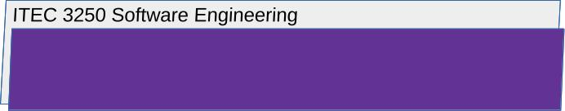

Requirements

1 Notes
- Number your responses as in the writeup, whether response is included or not
- To assist me in efficient scoring, use this document as a template, typing in your responses to each question.
- Your attention to detail in fully and concisely answering the question, will determine your score

2 This Assessment Covers

- Dependable Software Systems, with Textbook Chapter 10
- Reliability Engineering,with Textbook Chapter 11

3 What to Submit
lastnameFirstinitialA5.docx

All submitted files must be named with your first and last name as shown

4 Part 1: Dependable Software Systems, with Textbook Chapter 10

Answer the Following Questions

- Choose a mobile or desktop software application you have access to or can research, and then
briefly explain one way that this application does or could fail one of the dependability properties (reliability, safety, security, availability, resilience)
Then, argue how redundancy or software diversity could be used to help mitigate the failure
For a simple example, a mobile application might fail a security requirement by not implementing security services that prevent an attacker from intercepting and reading messages transmitted through a carrier network

5 Part 2: Reliability Engineering, with Textbook Chapter 11

Answer the Following Questions

- Briefly explain what you argue would be one functional reliability requirement and one non-functional reliability requirement of a mobile device application or desktop software application you have access to or can research
Remember that a reliability requirement is one that describes ‘what the system does’ (functional) or ‘what the system must be’ (non-functional) in order to achieve reliability.

6 Submission
For submissions to submission folders:

- Submit using the submission folder in D2L for this assignment
- For every assignment, create a new file to produce the submission
- Requirement: download or retrieve your submission after you submit it in order to check that your files are as you intend to be scored
- Resubmission is possible while the folder is open
- Latest scoreable submission is scored

